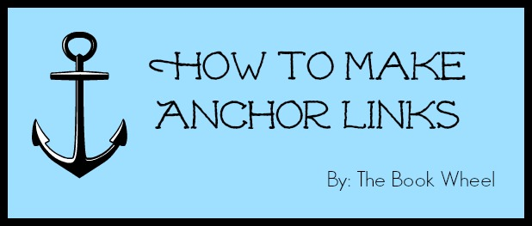

Please note: In some HTML editors, cutting and pasting the following codes will paste in the "" facing the wrong direction, resulting in a double-quotation that will render the links ineffective. If this happens, save your draft, reopen the HTML editor, and remove the extra inner quotations. You can check this by previewing the page and clicking each “link”. To avoid this, I recommend manually type the coding.

Title Coding:

<a href=“#A”>What</a> | <a href=“#B”>How</a> | <a href=“#C”>Help</a>

Pointed-To Anchor Links Coding:

<h3><a name=“A”></a>What</h3>

Back to Top Coding:

<p><em><span style=“color: #999999;”><small><a href=“#top”><span style=”color: #999999;”>Back to top</span></a></small></span></em></p>

Read more: http://www.thebookwheelblog.com/?p=8713#ixzz37ViHJU4d
Follow us: @thebookwheel on Twitter | thebookwheel on Facebook

